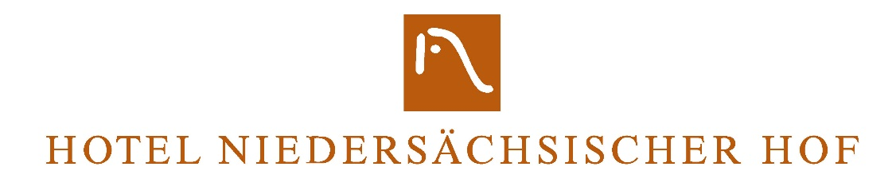

Hygiene concept
Dear guests,
we look forward to welcoming you again to the Hotel Niedersächsischer Hof in Goslar.
Since the current situation is very fragile and we are all working to ensure that we can continue to open our hotel, we ask you, in the interests of everyone, for your attention and follow to the instructions:
According to the current step-by-step plan from the state government of Lower Saxony
the 2Gplus regulation must now be applied in the area of accommodation.
We are only allowed to accommodate guests if you have one valid vaccination or convalescence certificate and additionally (on arrival and twice a week) a negative test can submit or a fully completed series of vaccinations and have the booster vaccination.
You can check-in with LUCA APP, this means that you are always registered
when you are in the hotel.

Please wear mouth and nose protection in all public areas, i.e. always outside of your room.
Medical masks FFP2 or surgical masks are suitable.

Please only use the elevator individually or with people in the common household / room.
Disinfection is available at all entrances and exits.
If you notice any Covid complaints, please report them (by phone) at the reception. You are not allowed to leave the hotel room. We will inform you about the further process and put you in contact with the health department.

Reception
Please always keep a minimum distance of 1.5 m from our employees and other guests. Please refrain from physical contact (shaking hands etc.).
Please note the plexiglass partitions at the reception and do not try to bypass them or to enter the reception.
You will receive a disinfected room card, please keep it with you. We would be happy if you pay your bill on the evening before your departure (cash or contactless with a card) in order to avoid queues at reception in the morning.

On the rooms
There are no restrictions in the rooms.
TV booklets, brochures, information material, hotel folders and accessories have to be removed, should you need anything, please report to reception.
The rooms will not be cleaned automatically every day during your stay.
We can clean your hotel room on request. Please open the window when you leave the room. Cleaning takes about 30 minutes.

Breakfast in the Rosengarten restaurant
During this difficult time there are breakfast restrictions.
We serve breakfast from 7 a.m. to 10 a.m., currently without scheduling.
Please select your wishes from the breakfast list and hand them in at the reception by 7 p.m.
Please do not sit down at a table yourself, wait in the entrance area with the necessary distance from other guests for a service employee who will escort you to a table.
You can only remove the mouth and nose protection after you have sat down at the table.
Your individual breakfast is served at your table.
If necessary, you can change your breakfast selection for the next day.
Use of the toilet is only possible in your room.

Our employees have been trained in our Corona house rules and are obliged to implement them at all times. Please follow the instructions of our employees at any time.

If you have any questions, our employees are at your disposal at any time.
We look forward to your visit,
Monika Sester
Director

